**Food Mine**

https://www.youtube.com/watch?v=Uci0L4k3TQo&list=PLpaspowtqj-dA0cRZ1yEZBv0iwdOru-SC&index=3&ab_channel=CodeWithNasir

|  |  |
| --- | --- |
|  | ##  Lessons |
| 2 | 1. Introduction to the course |
| 3 | 2. Install development tools |
| 4 | 3. Create Angular App |
| 5 | 1. Create project's folder |
| 6 | 2. Install @angular/cli |
| 7 | 3. Create App as frontend |

Instalando

*Npm install -g @angular/cli*

*Ng new frontend -–skip-tests*

*Ou*

*sudo npm install -g @angular/cli@13*

*Ou*

INSTALAR LOCALMENTE *sudo npm install @angular/cli@13*

*Npm install*

Criar past front end

*ng new frontend - -minimal*

*Y Y CSS*

*Cd frontend*

*Ng serve -o ou npm start*

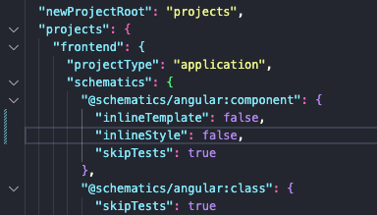

|  |  |  |
| --- | --- | --- |
|  | 4. Add Header 9 | 1. Generate Component |
| 10 | 2. Add Html |
| 11 | 3. Add Css |

*Ng g c components/partials/header*

Usar dois terminais para garatinr que um rode o codigo, e outro para commandos.

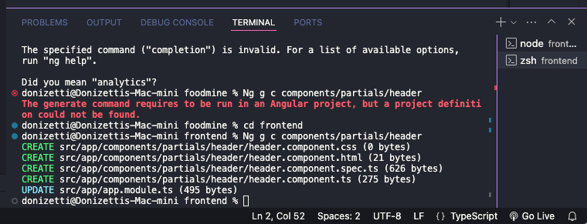

*Importando header no* app.component.html

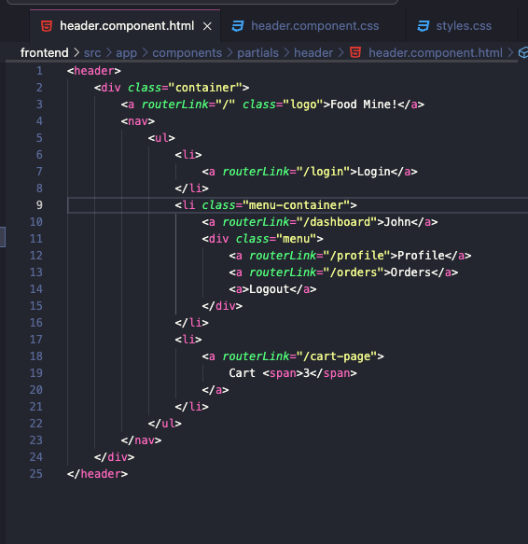

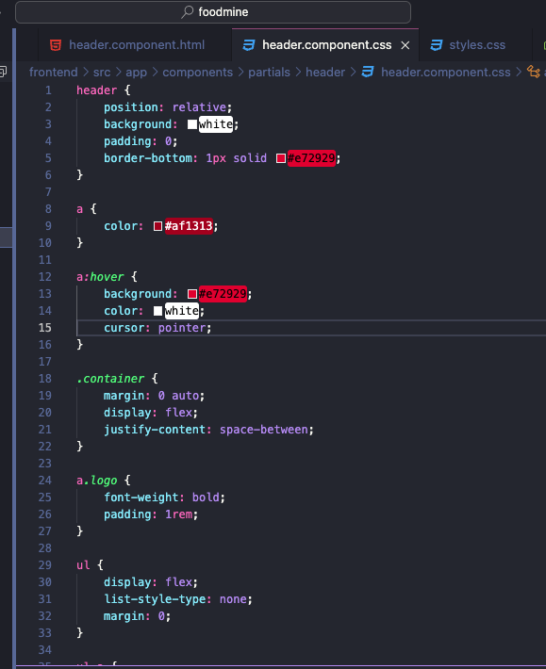

|  |  |
| --- | --- |
|  | 5. List Foods |
|  | 1. Create Food model |
|  | 2. Create data.ts |
|  | 1. Add sample foods |
|  | 3. Add images to assets |
|  | 4. Create Food service |
|  | 5. Create Home component |
|  | 1. Add ts |
|  | 2. Add html |
|  | 3. Add |

1

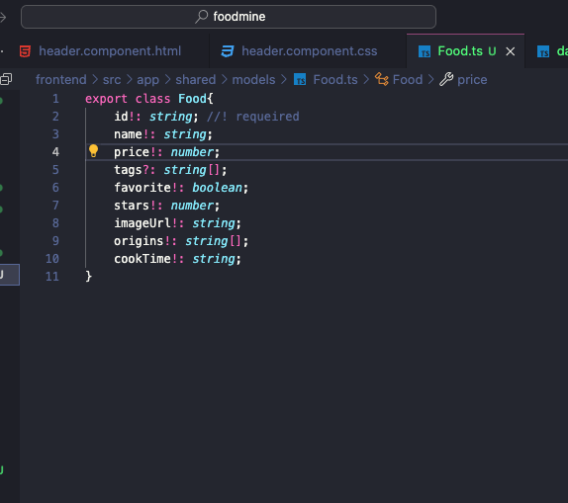

2

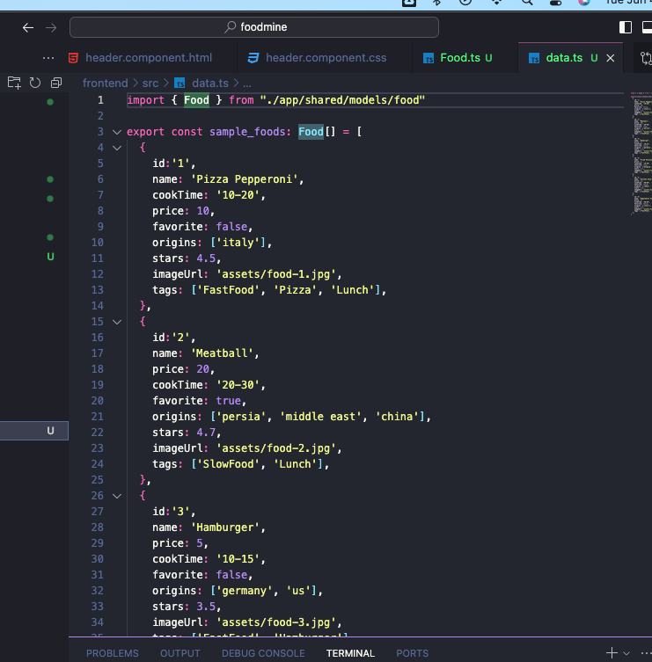

Import iamges

*ng g s service/food*

*cmd + .*

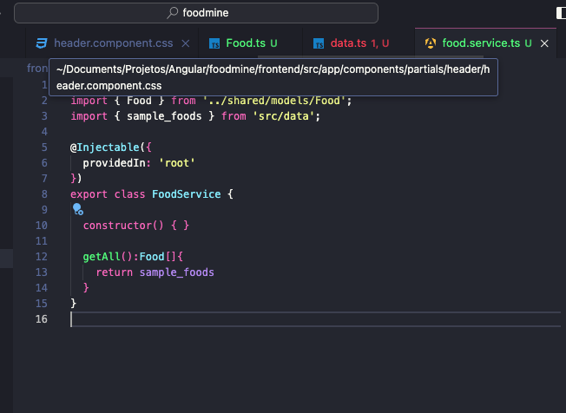

*5*

*ng g c components/pages/home*

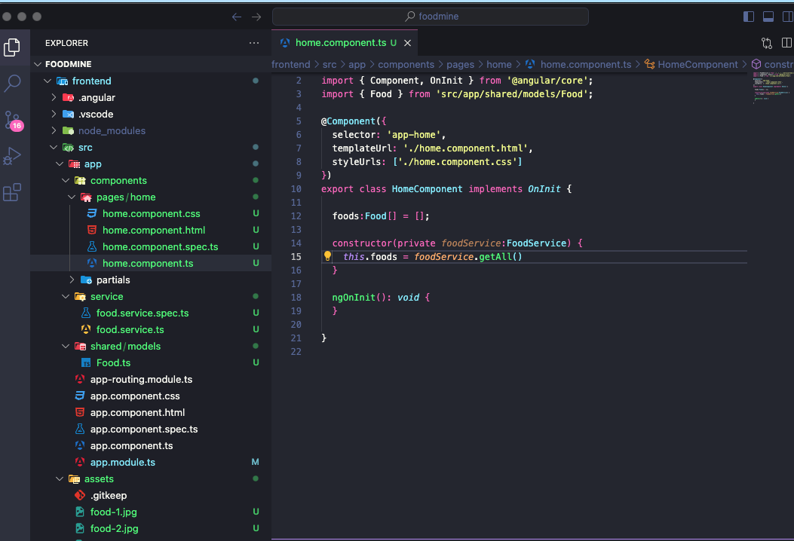

Instalar *npm install ng-starrating –force*

Importar em app modules

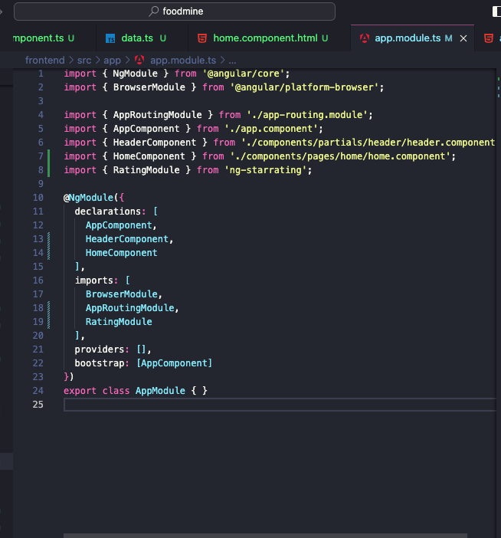

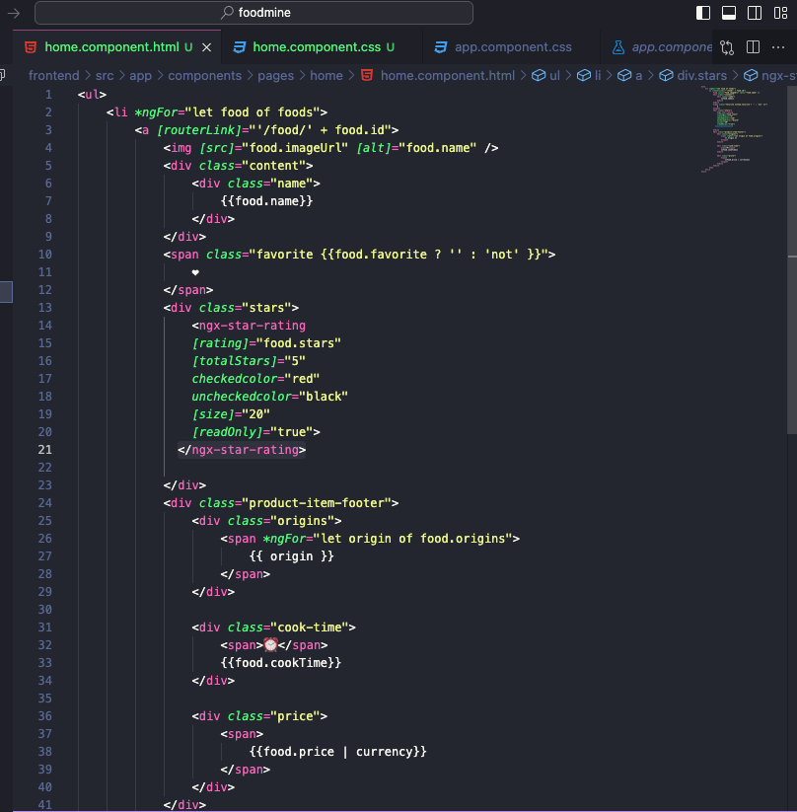

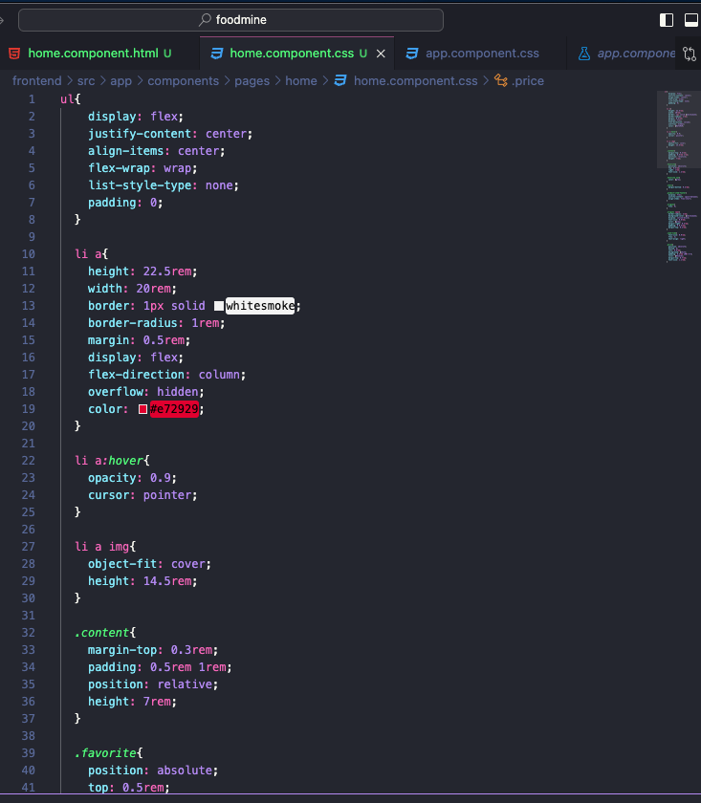

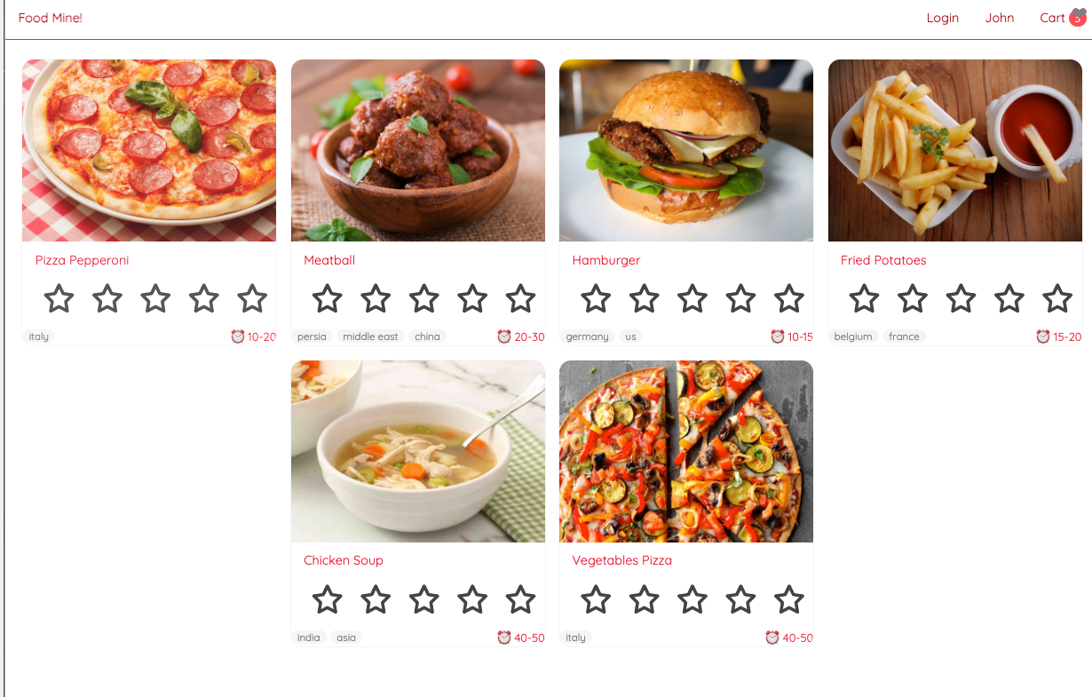

6. Search

1. ﻿﻿﻿Add method to Food service
2. ﻿﻿﻿Add search route
3. ﻿﻿﻿Show search result in Home component
4. ﻿﻿﻿Generate search component
5. ﻿﻿﻿Add to home component
6. ﻿﻿﻿Add ts
7. ﻿﻿﻿Add html

﻿﻿﻿Add css

1

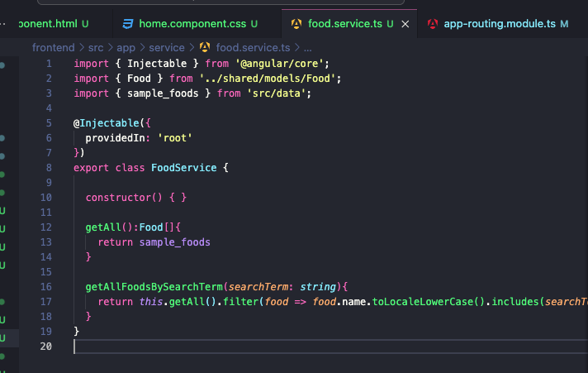

2

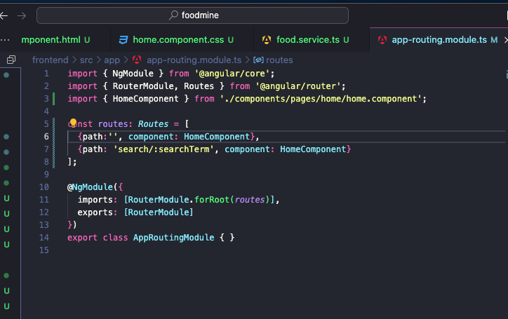

3

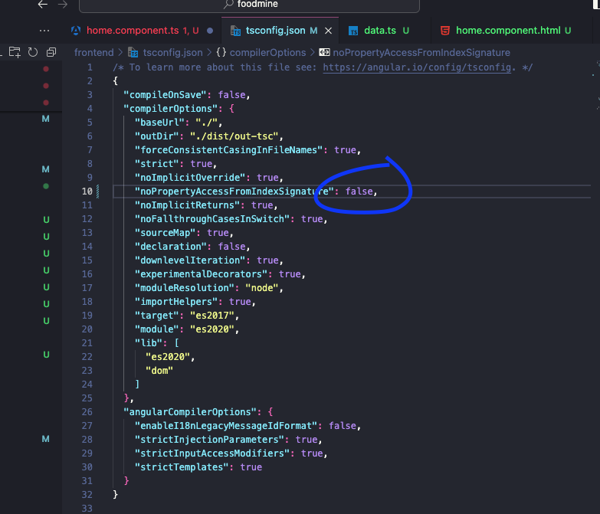

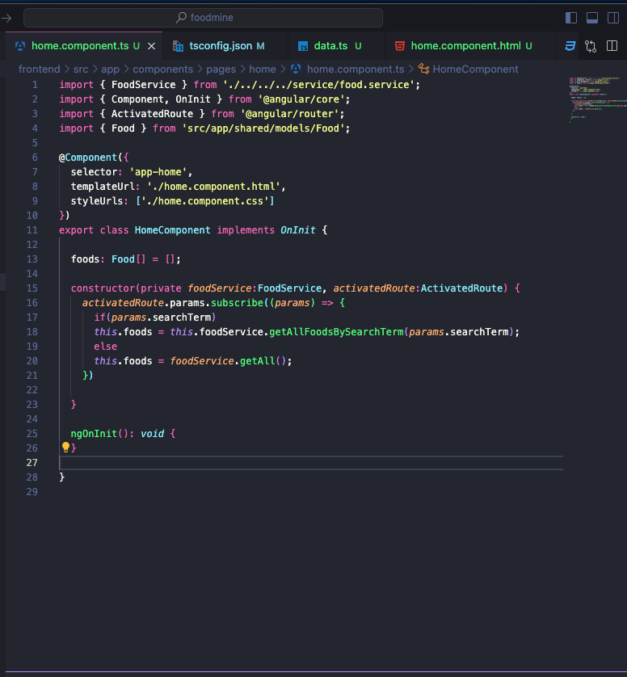

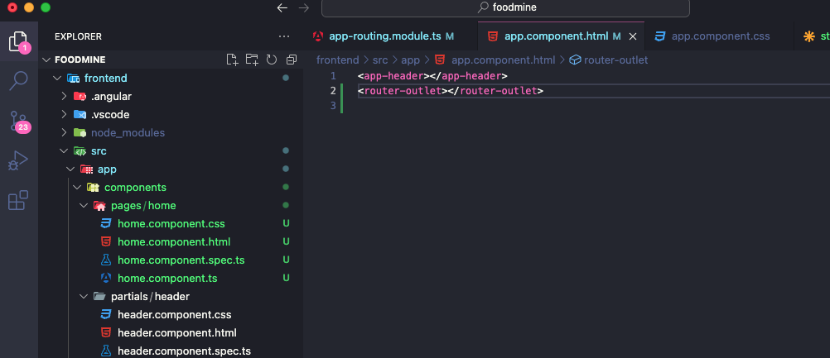

4

*ng g c components/partials/search*

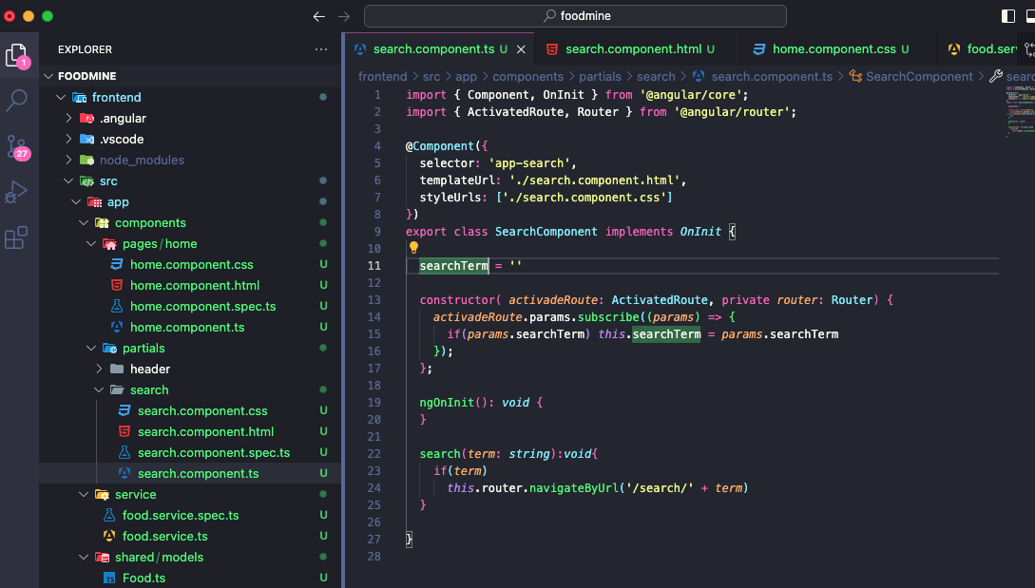

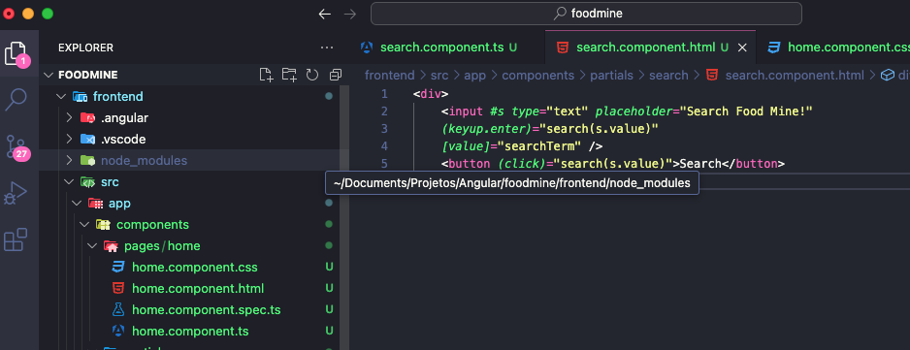

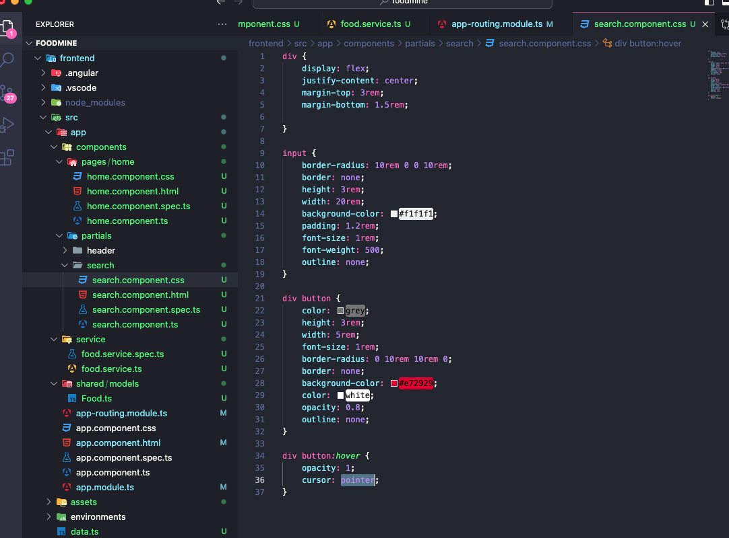

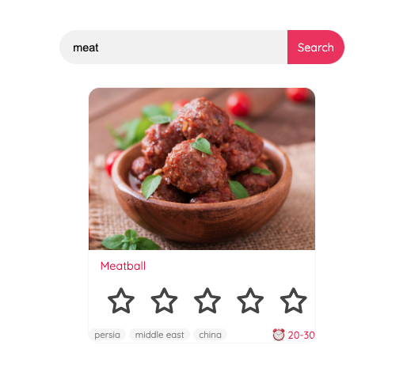

8. Food Page

1. ﻿﻿﻿Add method to food service
2. ﻿﻿﻿Generate Food Page component
3. ﻿﻿﻿Add Route
4. ﻿﻿﻿Add ts
5. ﻿﻿﻿Add html

﻿﻿﻿Add css

5

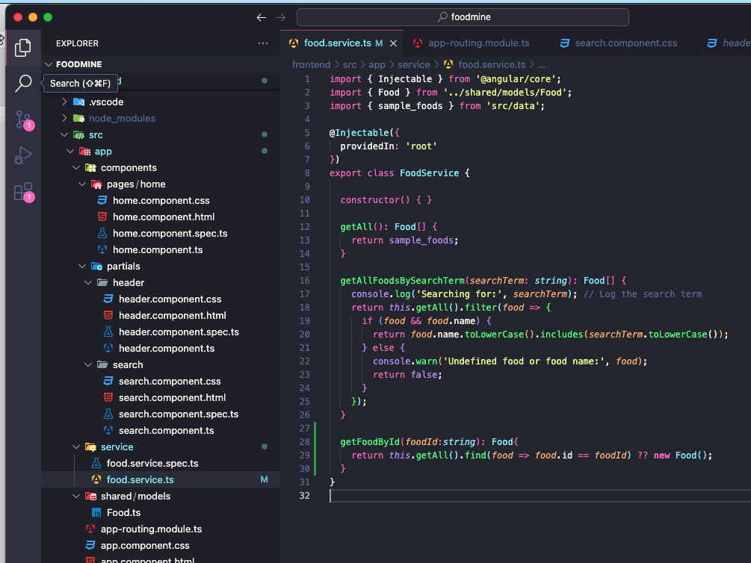

*ng g c components/pages/food-page*

*4*

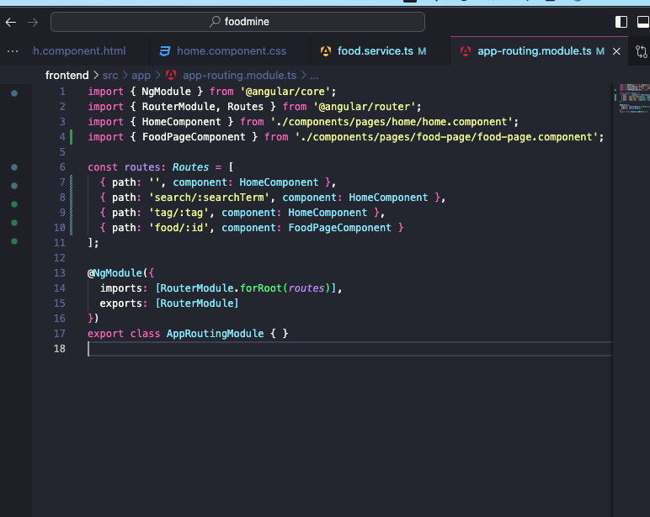

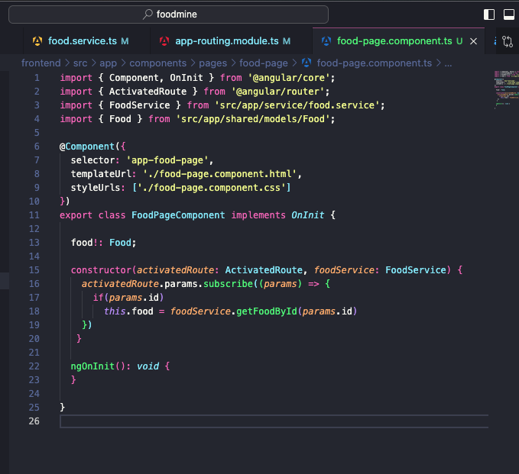

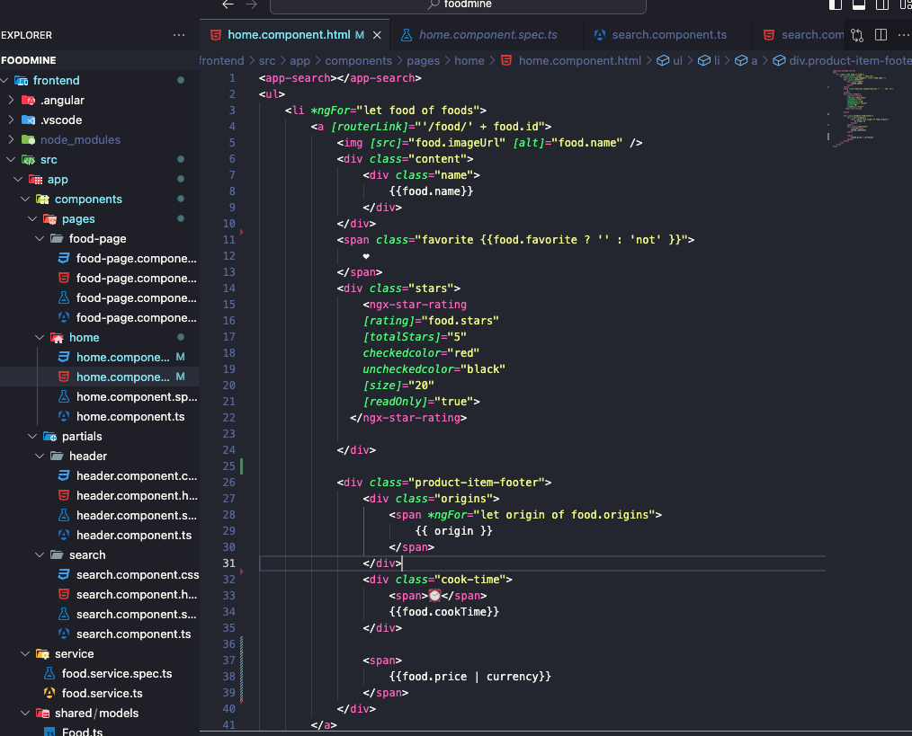

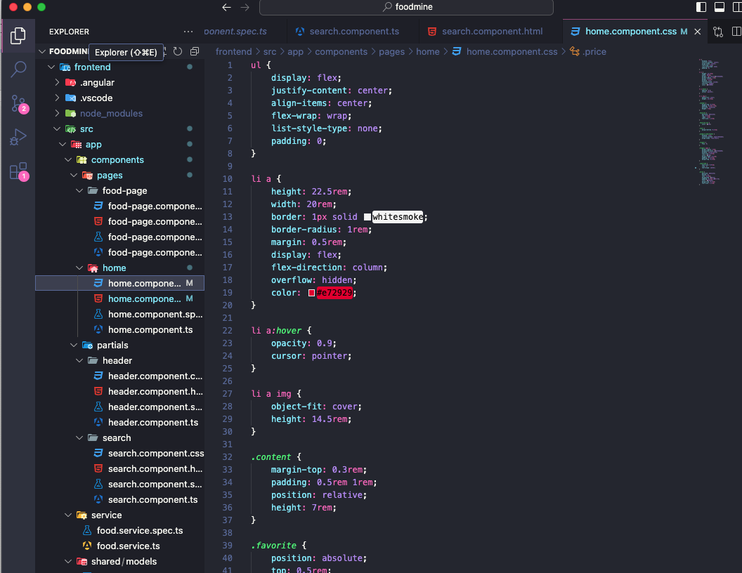

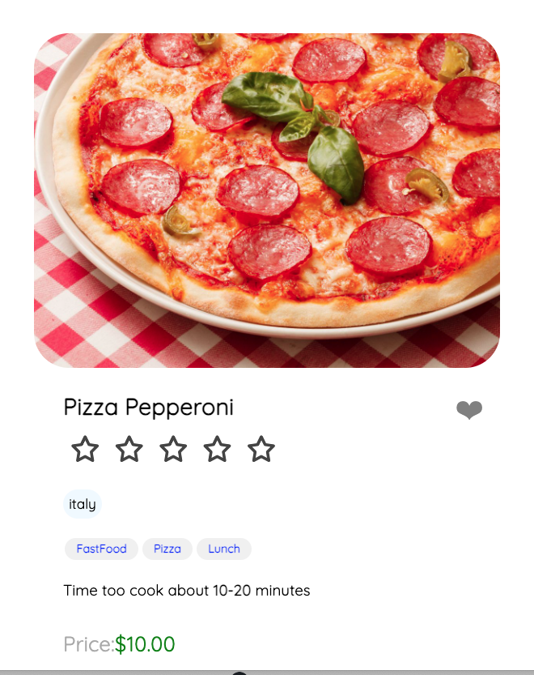

7. Tags Bar

|  |  |
| --- | --- |
|  | 1. Create Tag model |
|  | 2. Add sample tags to data.ts |
|  | 3. Food service |
|  | 1. Add get all tags method |
|  | 2. Add get all foods by tag method |
|  | 4. Add tags route |
|  | 5. Show tag result in Home component |
|  | 6. Generate Tags component |
|  | 1. Add to home component |
|  | 2. Add ts |
|  | 3. Add html |
|  | 4. Add css |

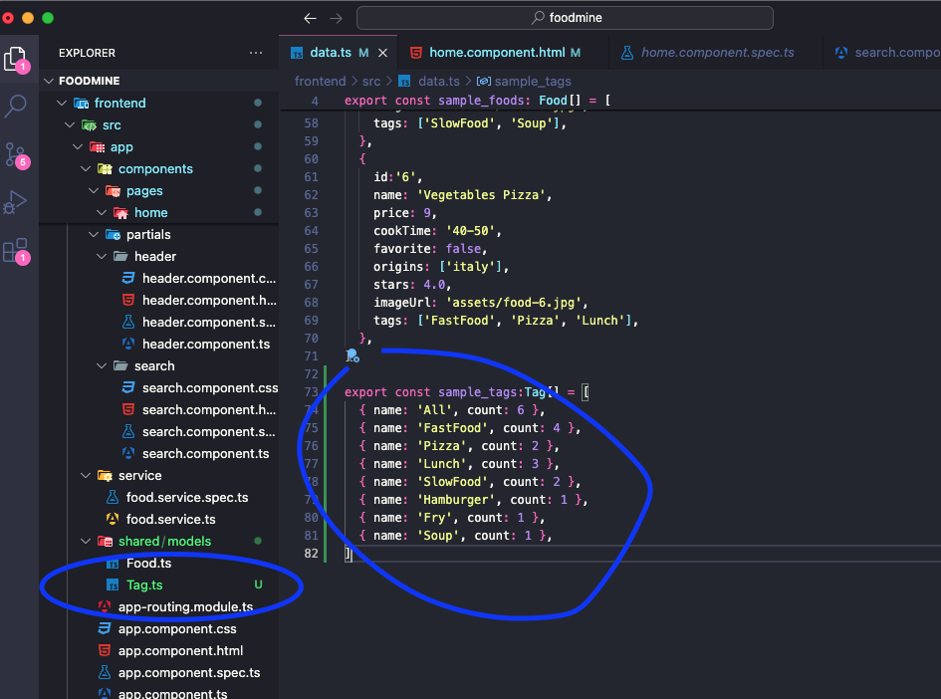

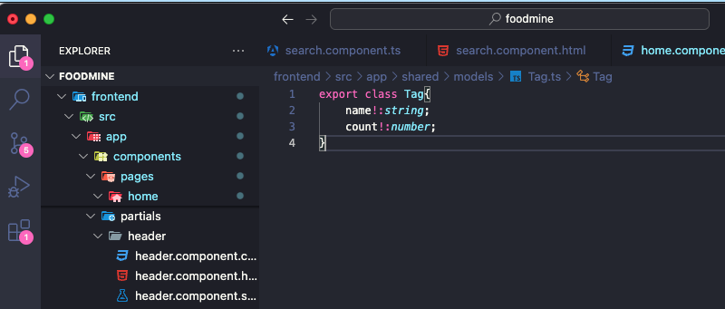

*31 32*

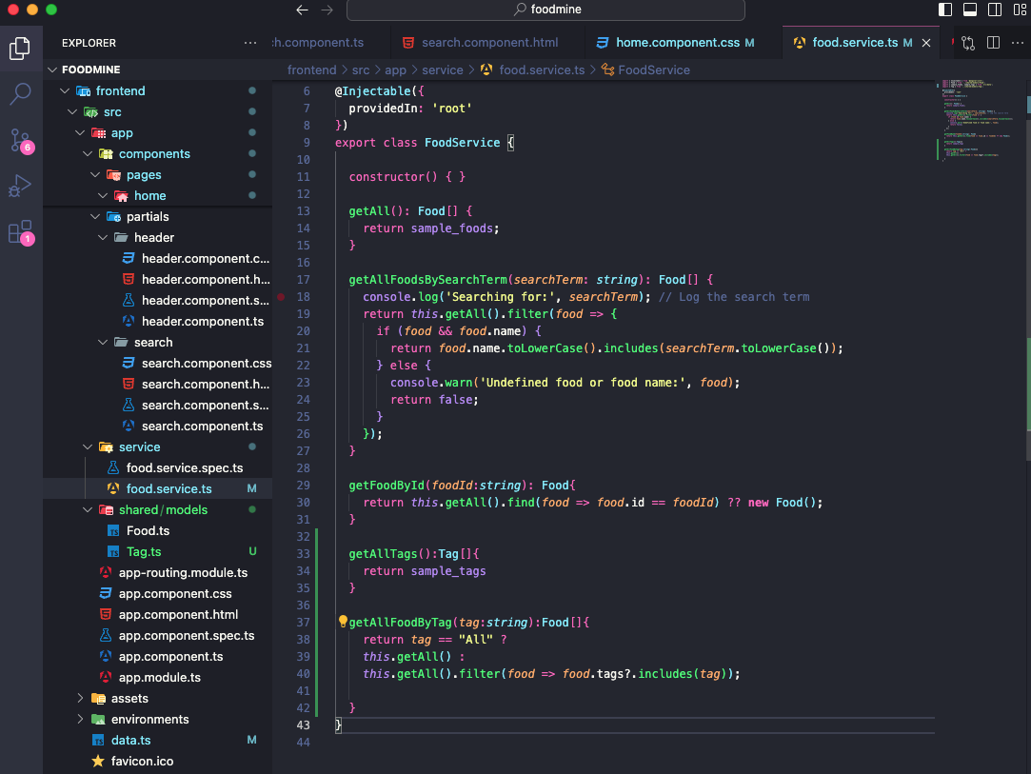

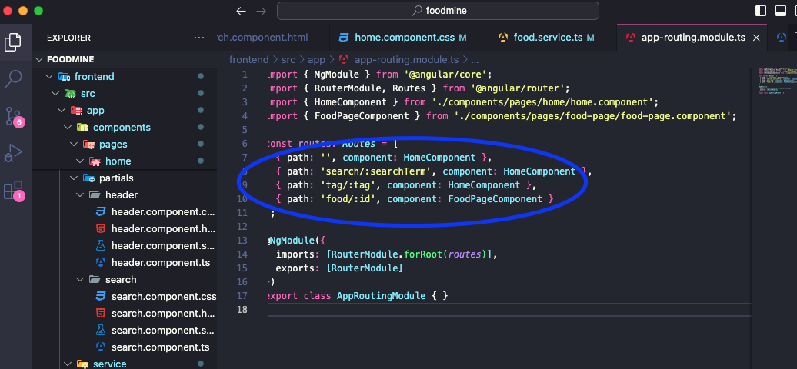

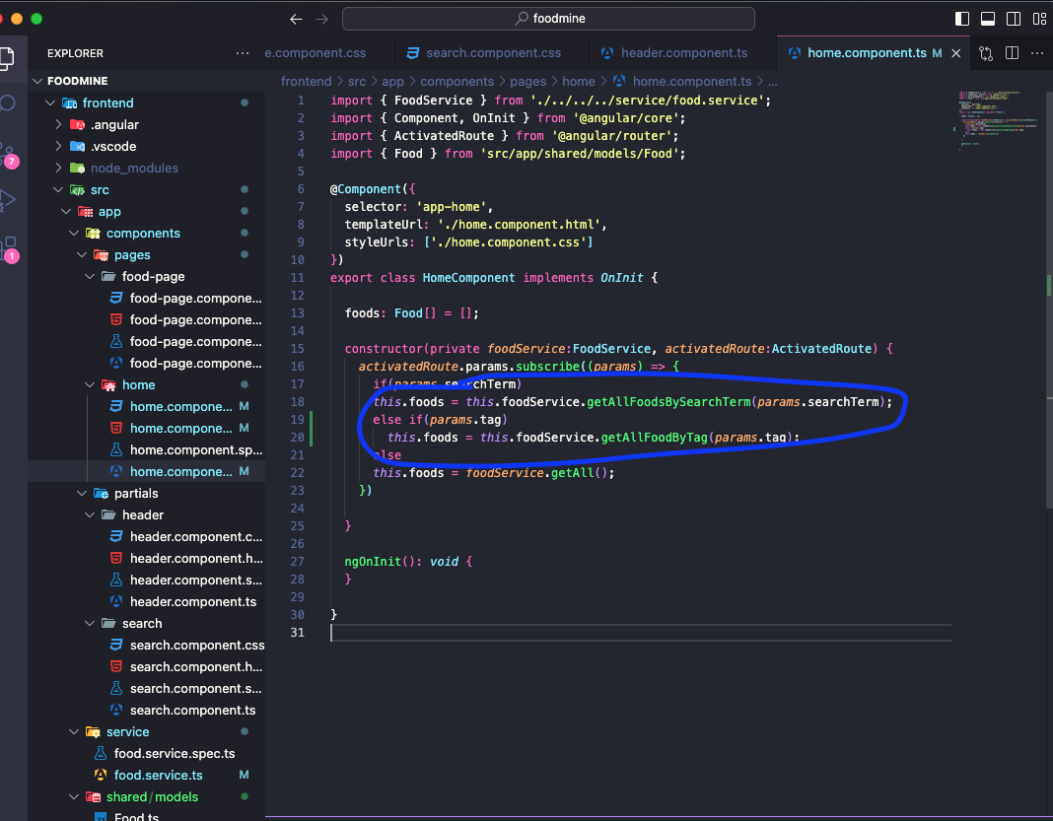

*ng g c components/partials/tags*

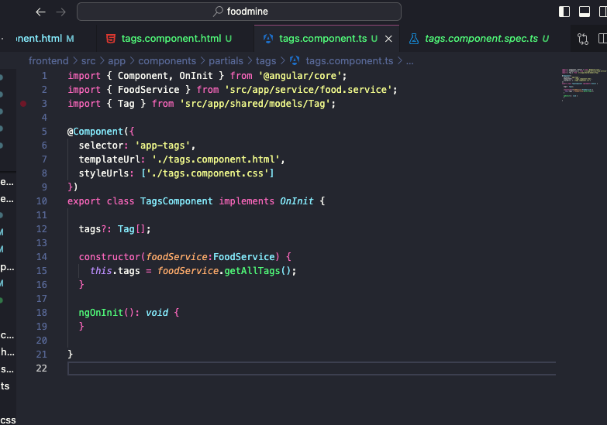

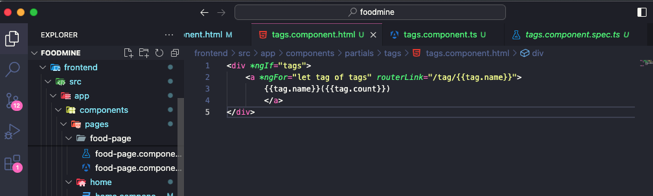

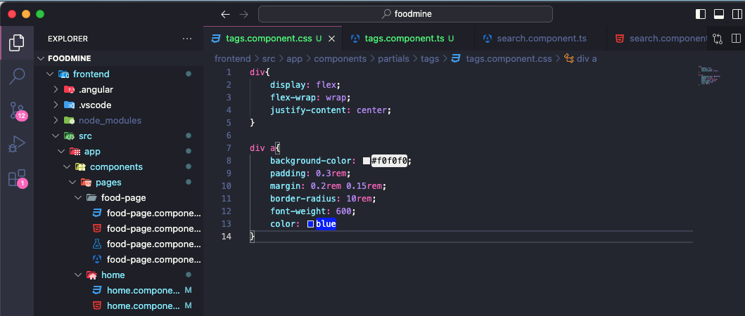

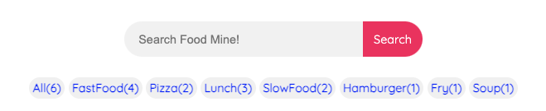

*8*

*Cart Page*

*1. Create CartItem Model*

*2. Create Cart Model*

*3. Generate Cart service*

*4. Add to Cart Button in Food Page*

*5. Generate Cart page component*

*1. Add Route*

*2. Add ts*

*3. Add html*

*4. Add css*

*1*

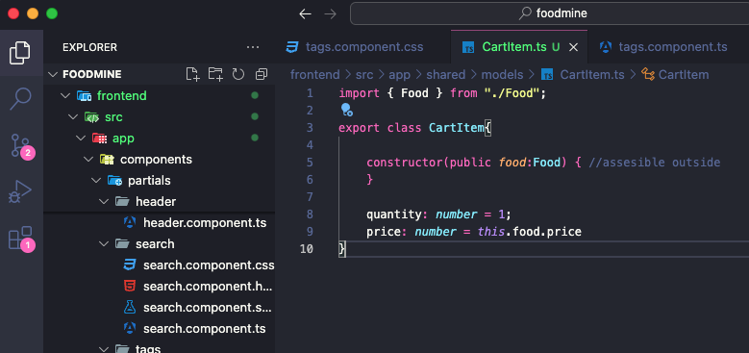

*2*

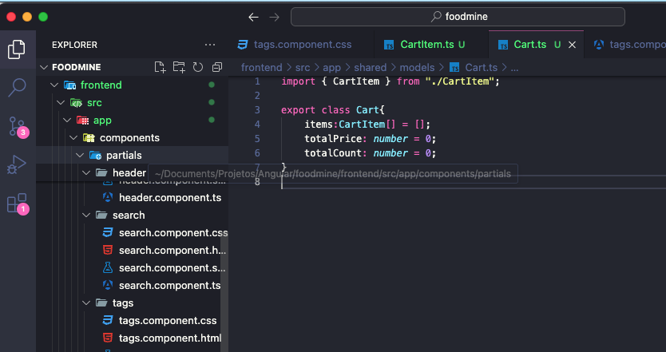

*3*

*ng g s service/cart*

[*https://www.youtube.com/watch?v=mLqBQVexy0c&list=PLpaspowtqj-dA0cRZ1yEZBv0iwdOru-SC&index=8&ab_channel=CodeWithNasir*](https://www.youtube.com/watch?v=mLqBQVexy0c&list=PLpaspowtqj-dA0cRZ1yEZBv0iwdOru-SC&index=8&ab_channel=CodeWithNasir)

Carrinho de compras - DIFICL

*4*

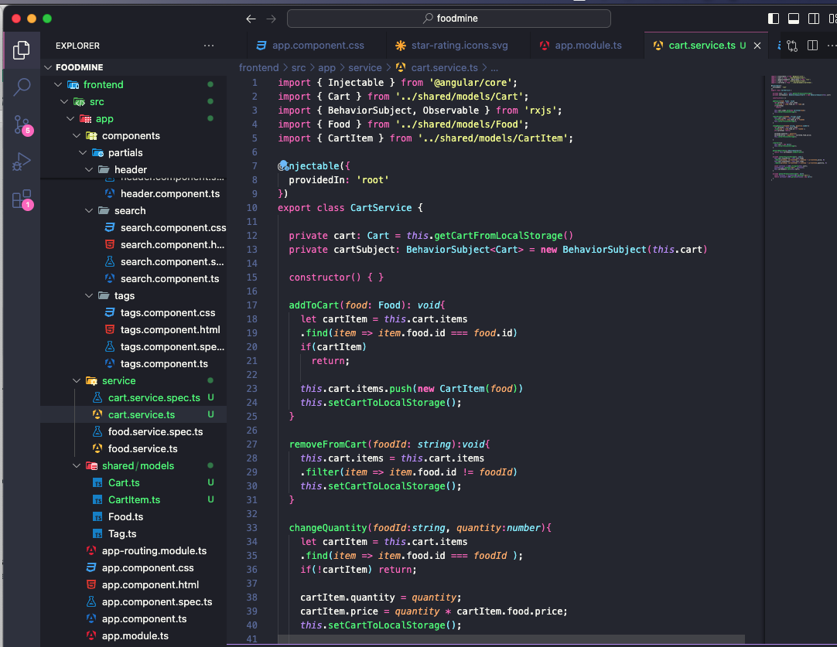

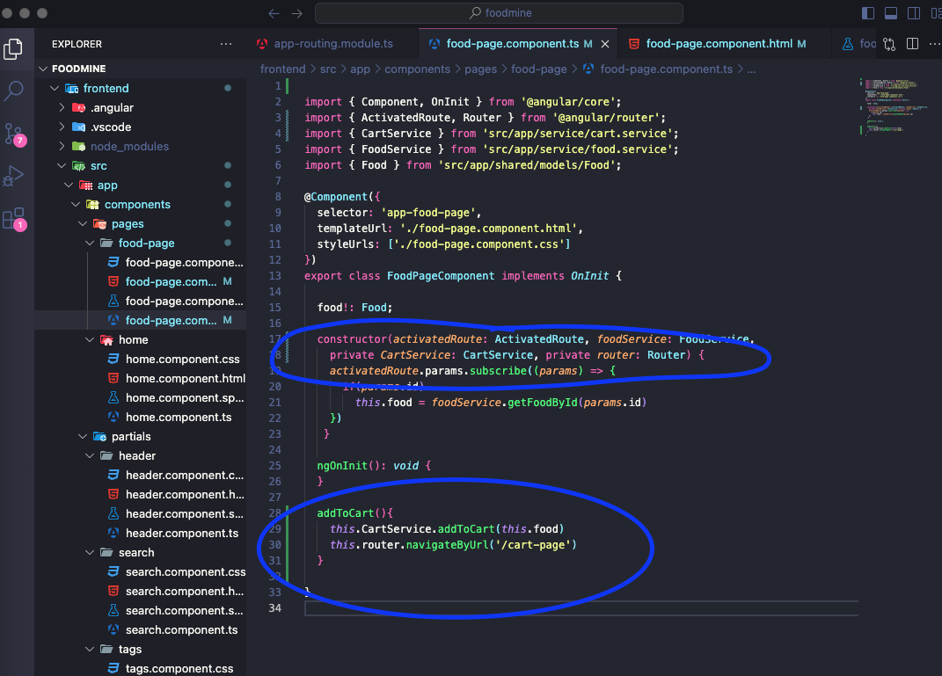

*ng g c components/pages/cart-page*

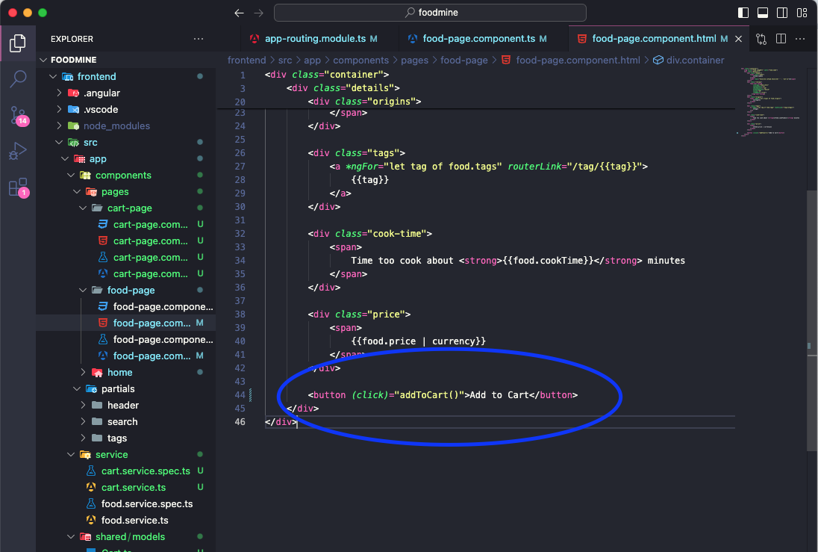

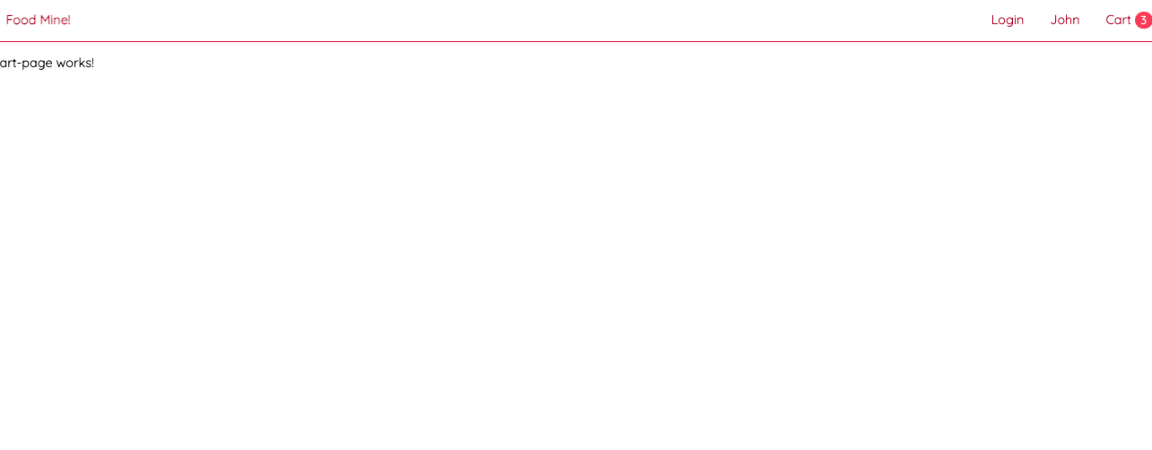

8. Cart Page

1. ﻿﻿﻿Create CartItem Model
2. ﻿﻿﻿Create Cart Model
3. ﻿﻿﻿Generate Cart service
4. ﻿﻿﻿Add to Cart Button in Food Page
5. ﻿﻿﻿Generate Cart page component
6. ﻿﻿﻿Add Route
7. ﻿﻿﻿Add ts I
8. ﻿﻿﻿Add html

﻿﻿﻿Add css

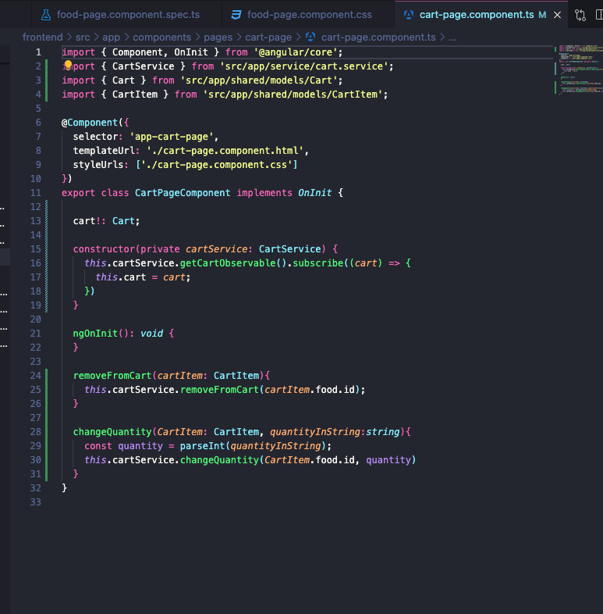

*ng g c components/partials/title*

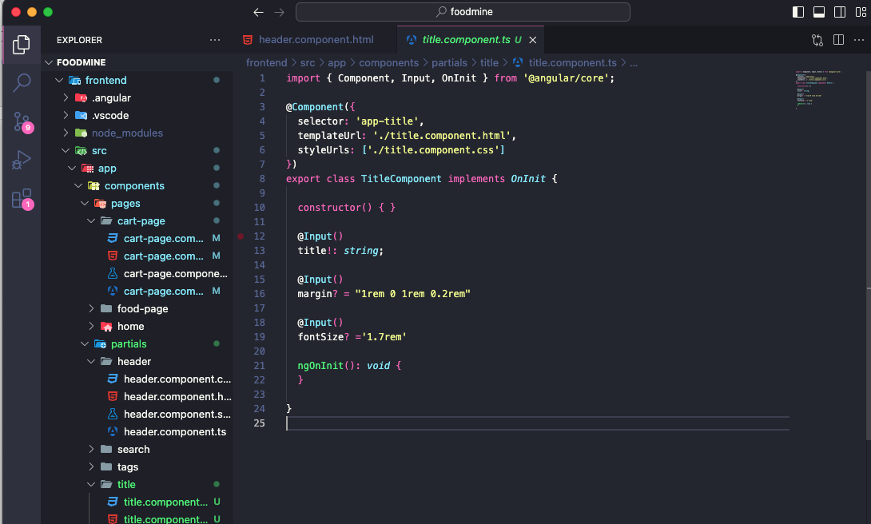

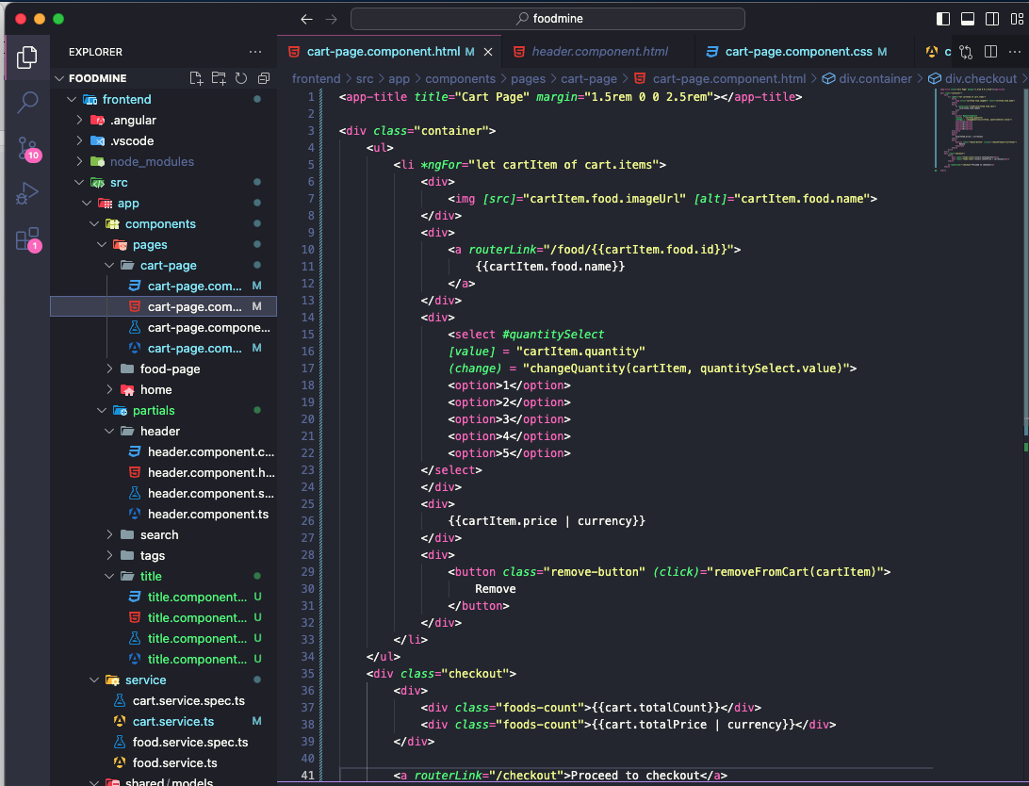

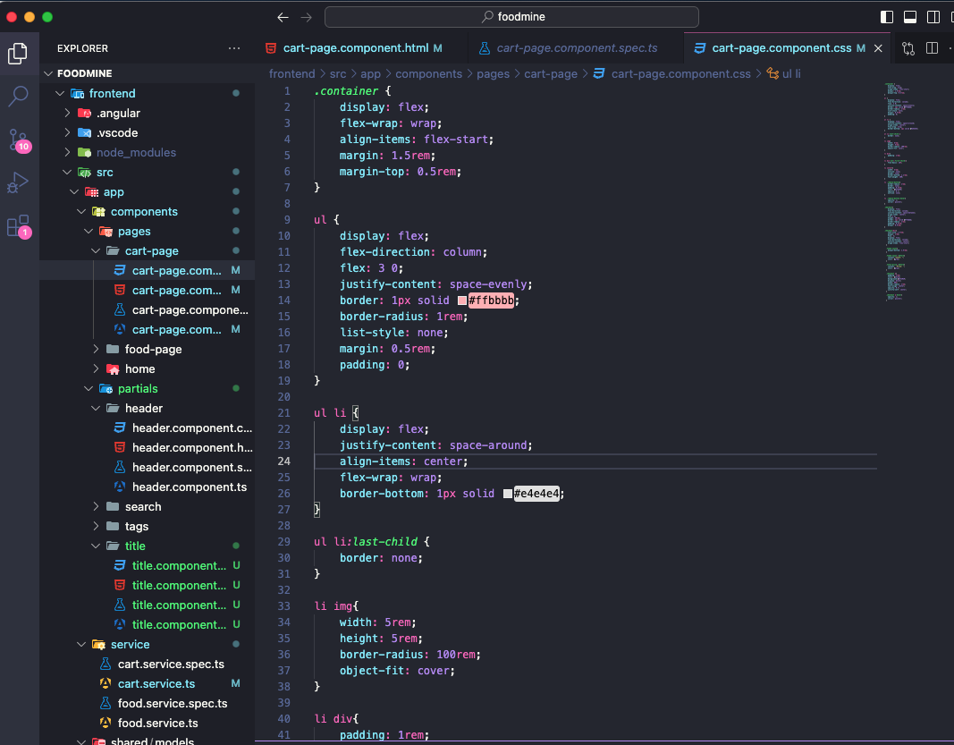

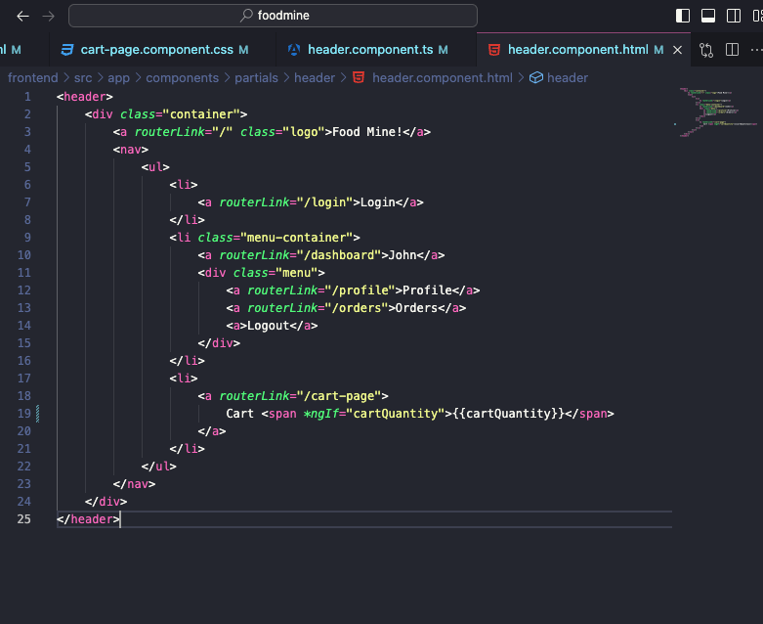

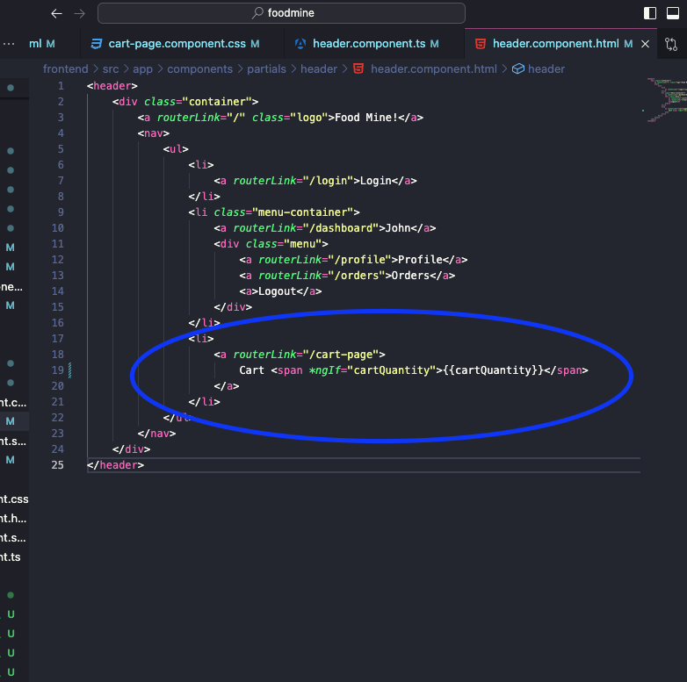

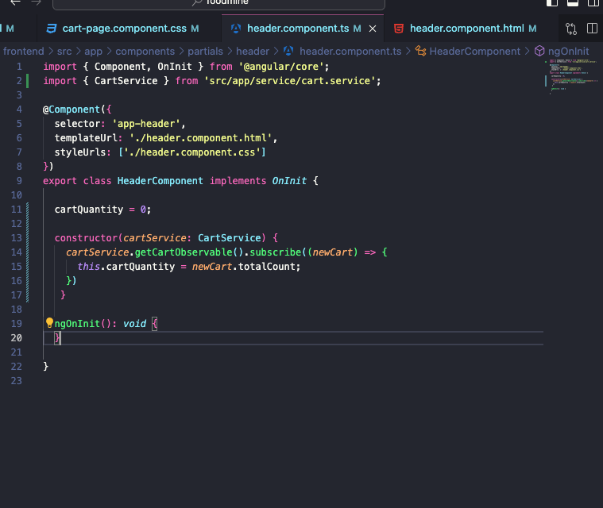

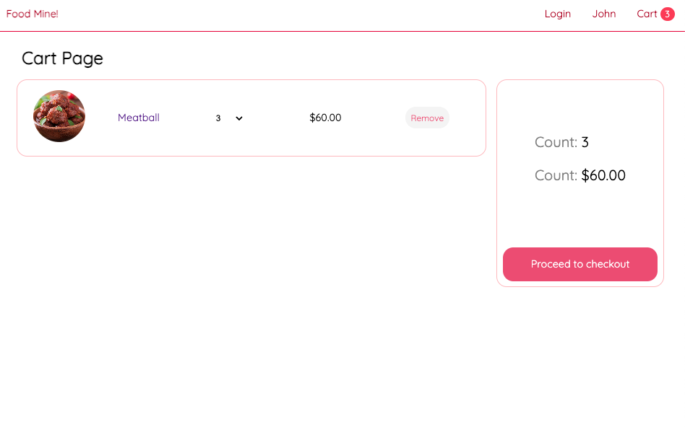

Not found

10. Not Found!

1. Generate Component

1. ﻿﻿﻿Add ts
2. ﻿﻿﻿Add html
3. ﻿﻿﻿Add css

2. Add To Pages

1. ﻿﻿﻿Home Page
2. ﻿﻿﻿Food Page

﻿﻿﻿Cart Page

1

Ng g c components/partials/not-found

2

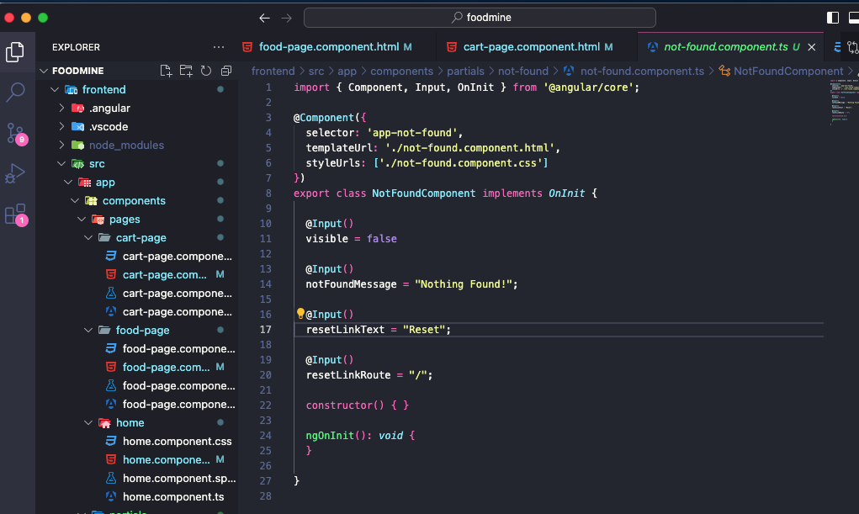

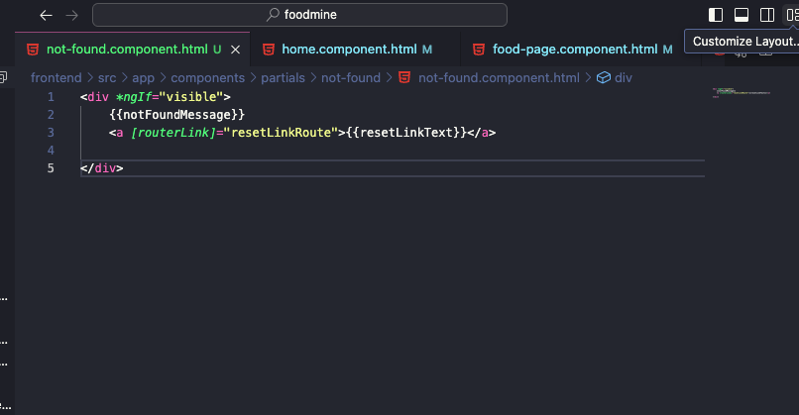

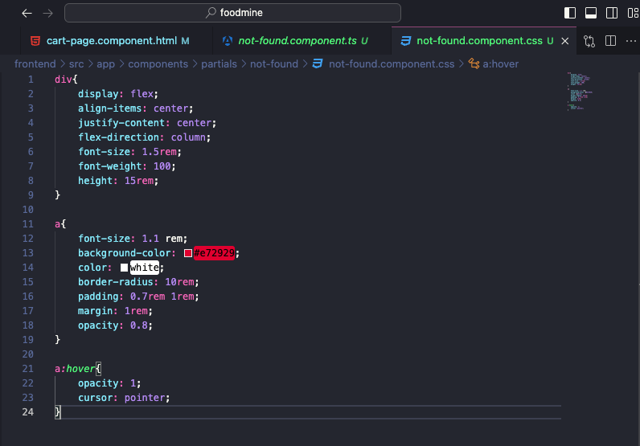

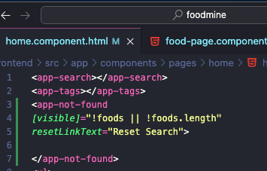

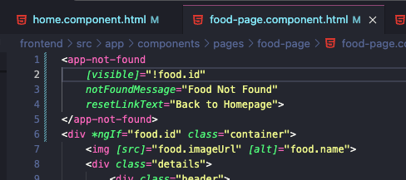

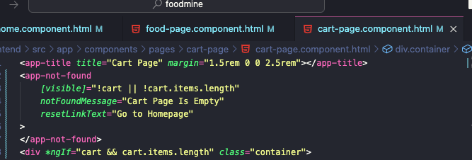

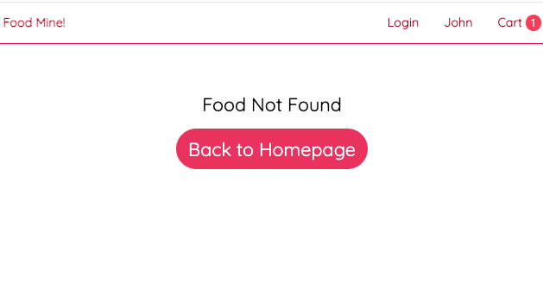

Connect To Backend

1. ﻿﻿﻿Create backend folder
2. ﻿﻿﻿npm init
3. ﻿﻿﻿npm install typescript
4. ﻿﻿﻿Create tsconfig json
5. ﻿﻿﻿Create • gitignore
6. ﻿﻿﻿Copy data.ts to backend/src
7. ﻿﻿﻿npm install express cors
8. ﻿﻿﻿Create server.ts
9. ﻿﻿﻿install @types
10. ﻿﻿﻿Add Apis
11. ﻿﻿﻿npm install nodemon ts-node --save-dev
12. ﻿﻿﻿﻿Add urs.ts to frontend

esta

1. ﻿﻿﻿﻿Add HttpClient module

﻿﻿﻿﻿Update food

*Npm init -y*

pasta backend

*npm install typescript*

Criar arquivo tsconfig.json e colar

{

"compilerOptions": {

"module": "CommonJS",

"moduleResolution": "node",

"strict": true,

"outDir": "./built",

"experimentalDecorators": true,

"emitDecoratorMetadata": true,

"esModuleInterop": true

},

"include": ["src/**/*"],

}

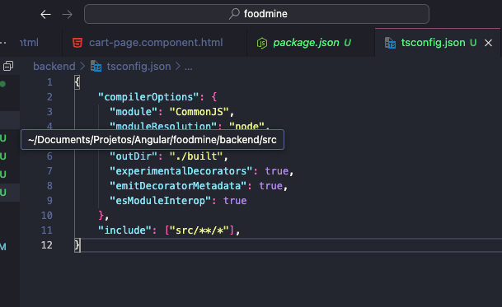

Criar arquivo .gitignore

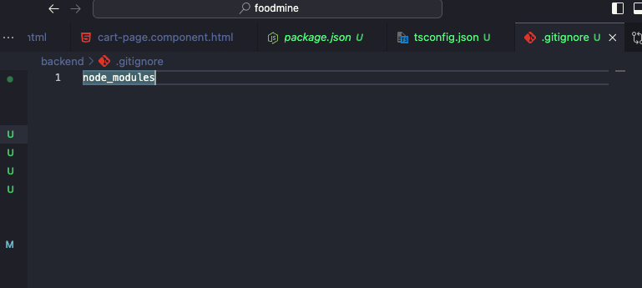

Copiando data.ts para pasta src dentro de backend

*Npm install express*

*sudo npm install @types/express*

*Npm install cors*

*sudo npm install @types/cors*

Criara arquivo server.ts

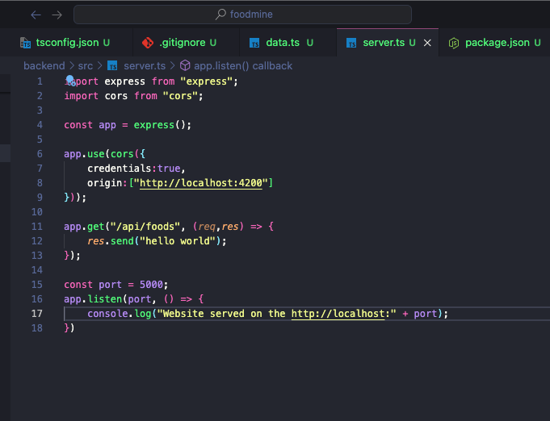

*sudo npm install ts-node --save-dev //converter para javascript*

*sudo npm install nodemon – save-dev*

Adding start

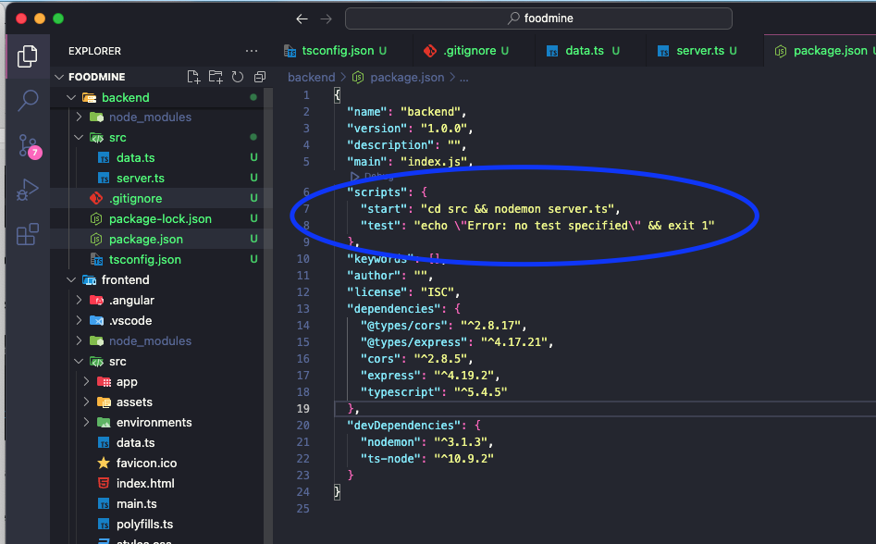

*Npm start*

*Instal json formater extension*

Implementar todos os metodos em food.service.ts no backend side

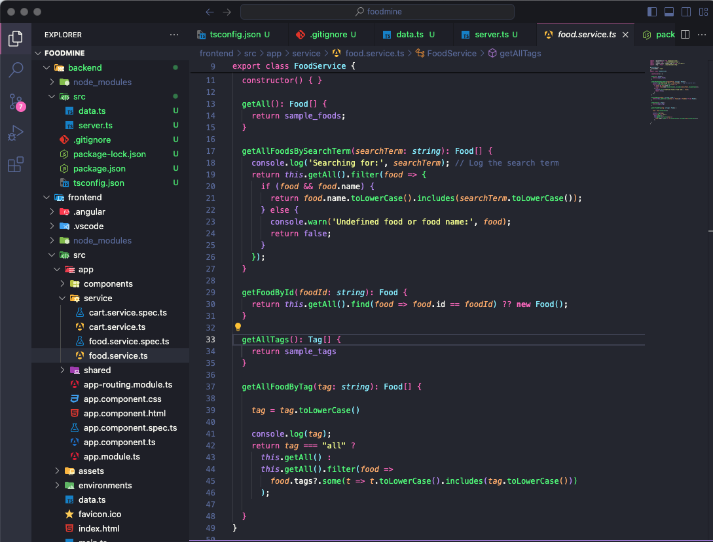

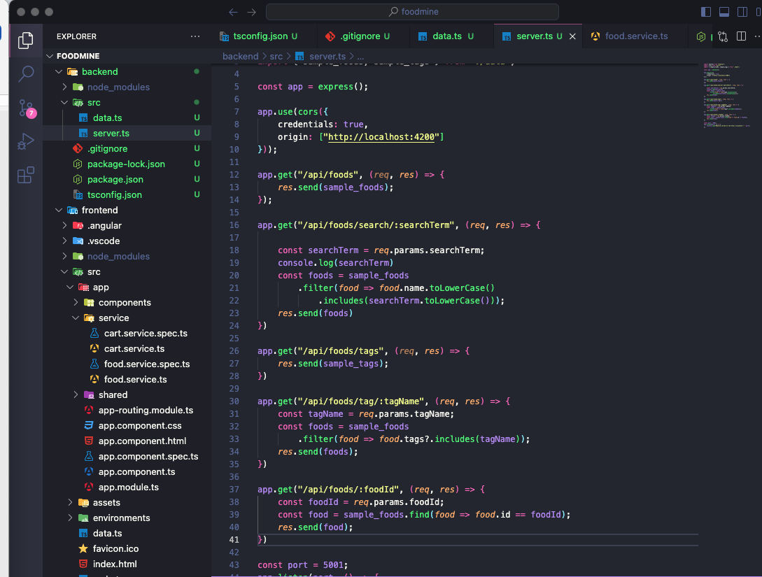

10 adding urs.ts

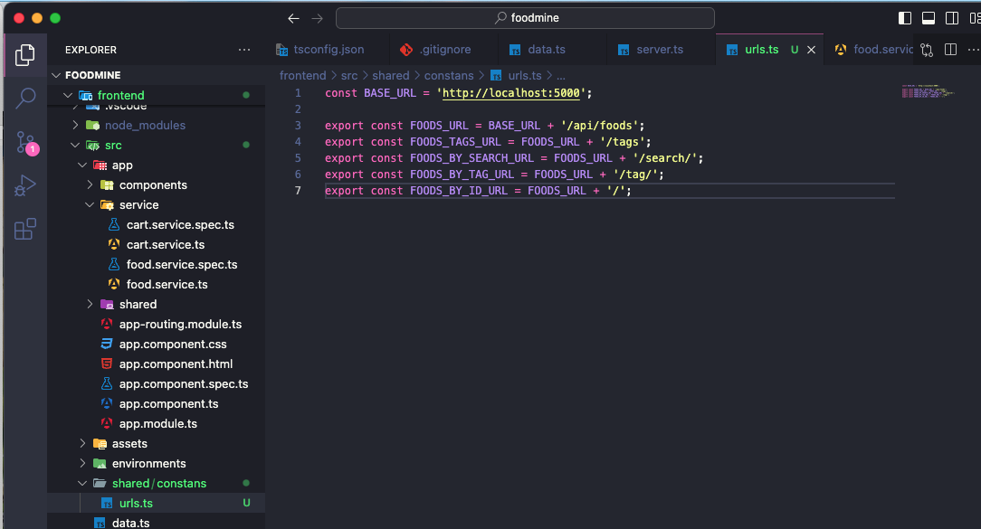

Adding http client module

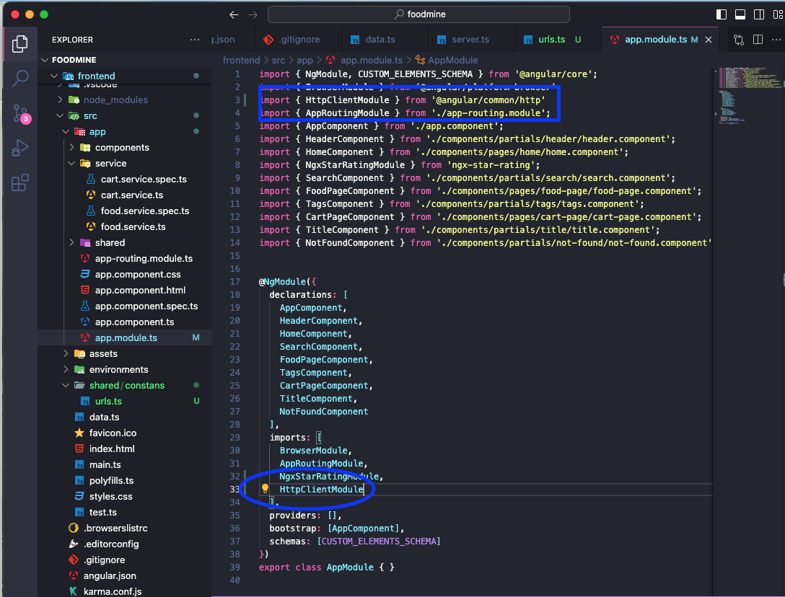

Atualizar food service

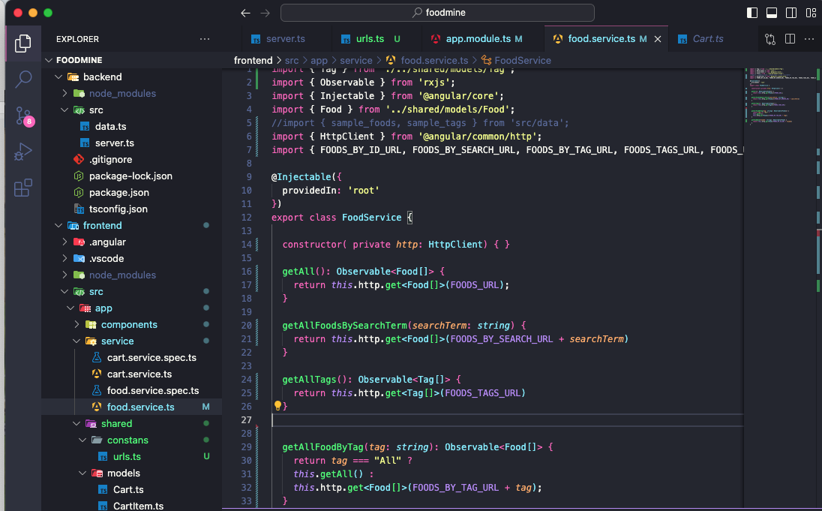

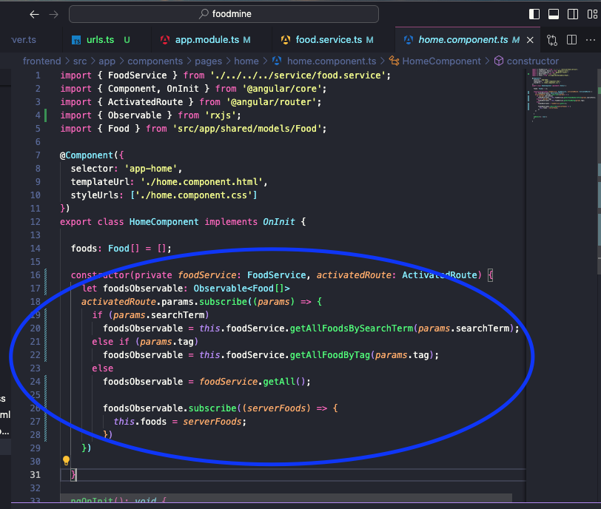

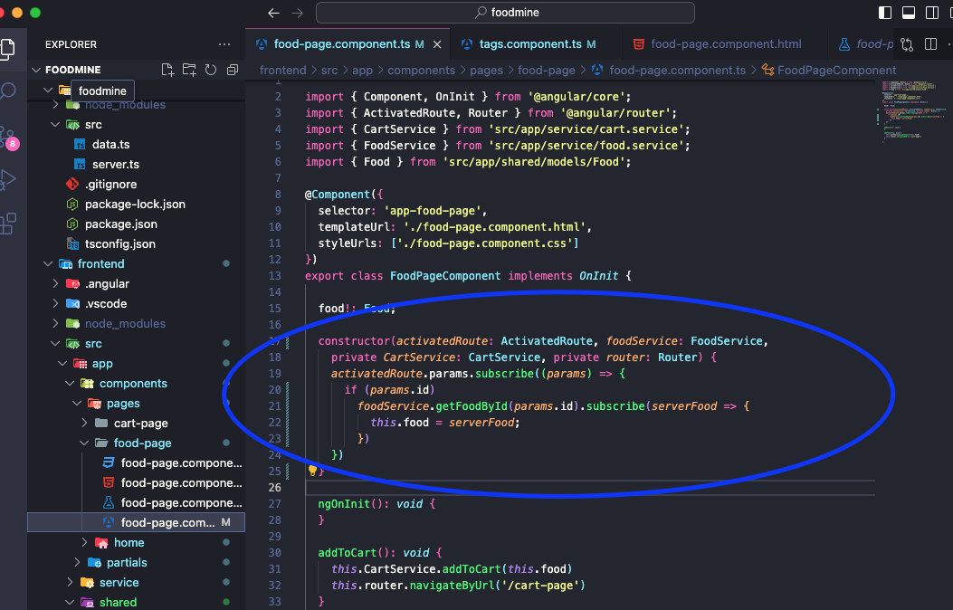

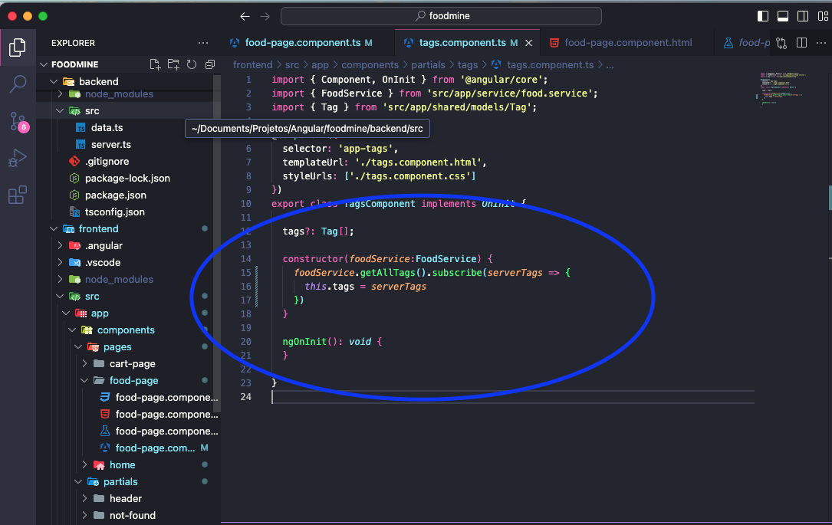

Error id

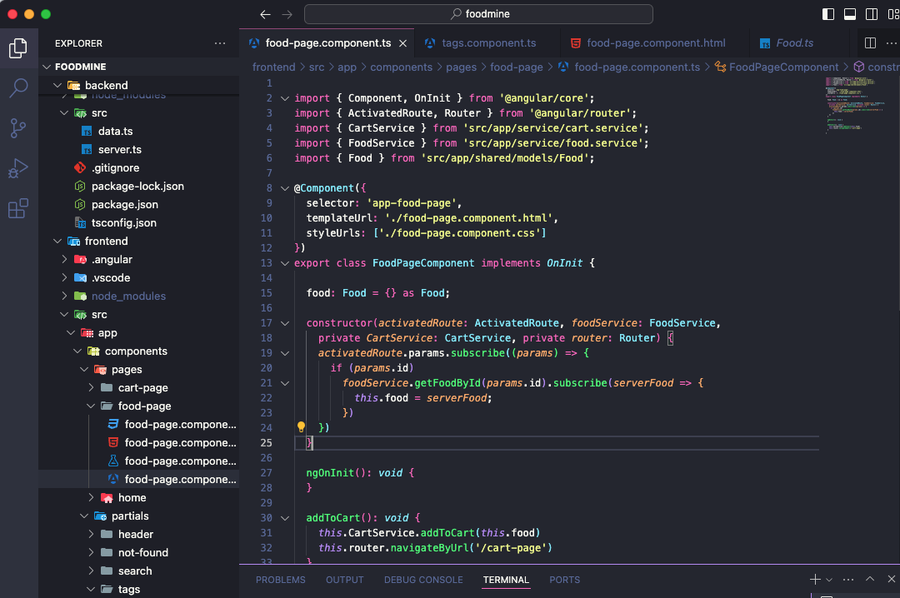

Backend connect with frontend

12. Login Page

1. Generate Component

1. ﻿﻿﻿Add to routes
2. ﻿﻿﻿Add ts
3. ﻿﻿﻿Add html

1. Import Reactive Forms Module

4. Add Css

2. Add Login Api

1. Use json

I

1. ﻿﻿﻿Add jsonwebtoken
2. ﻿﻿﻿Test Using Postman

3. Part 2

*ng g c components/pages/login-page*

criando rota

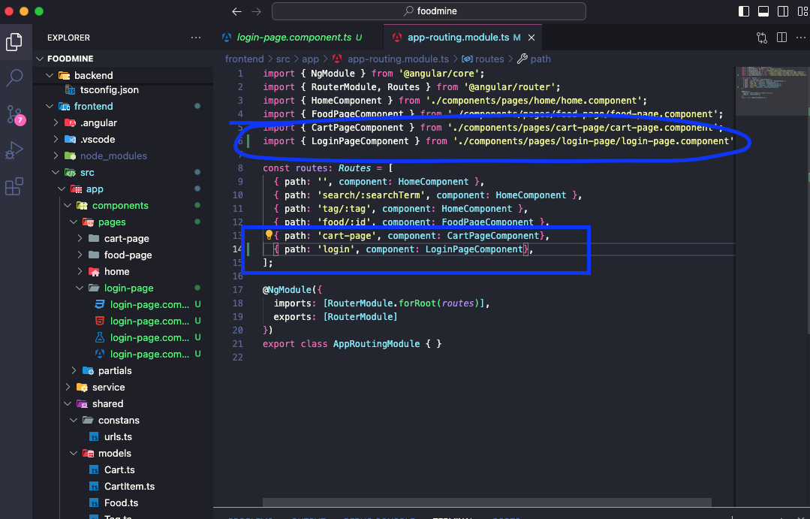

Importer modulos

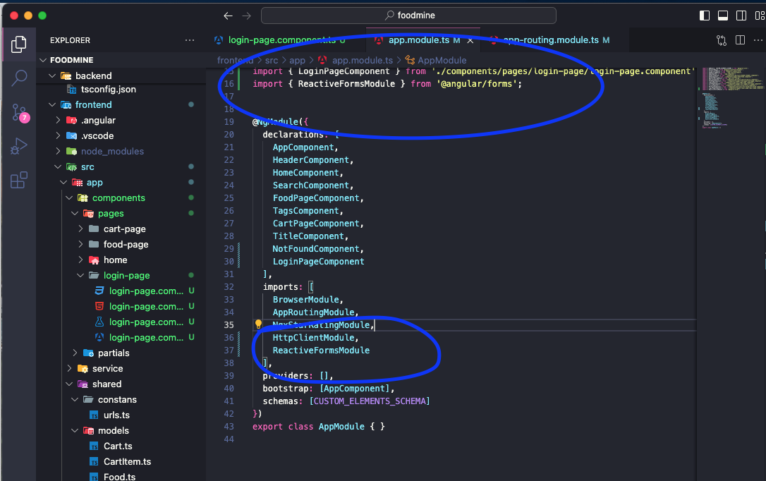

24 Add ts

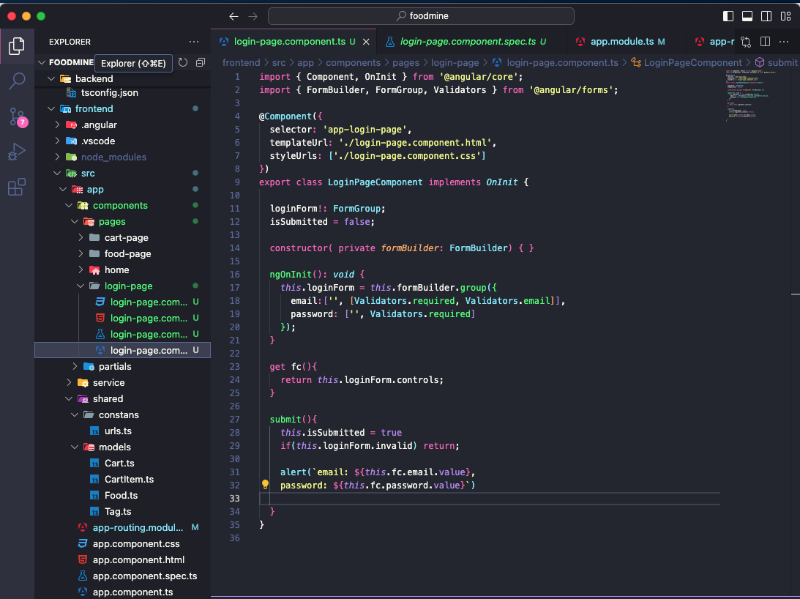

Add html

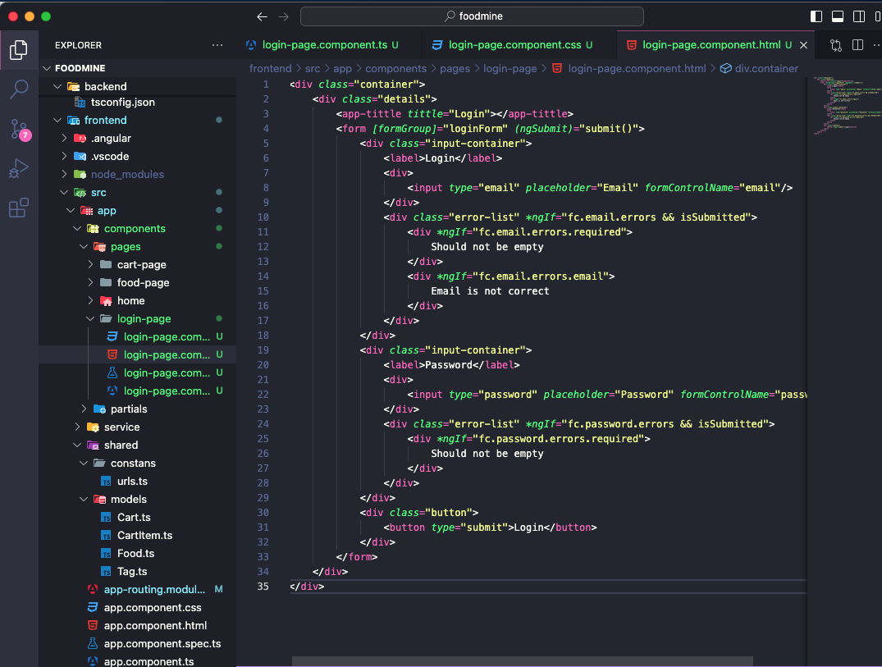

Add css

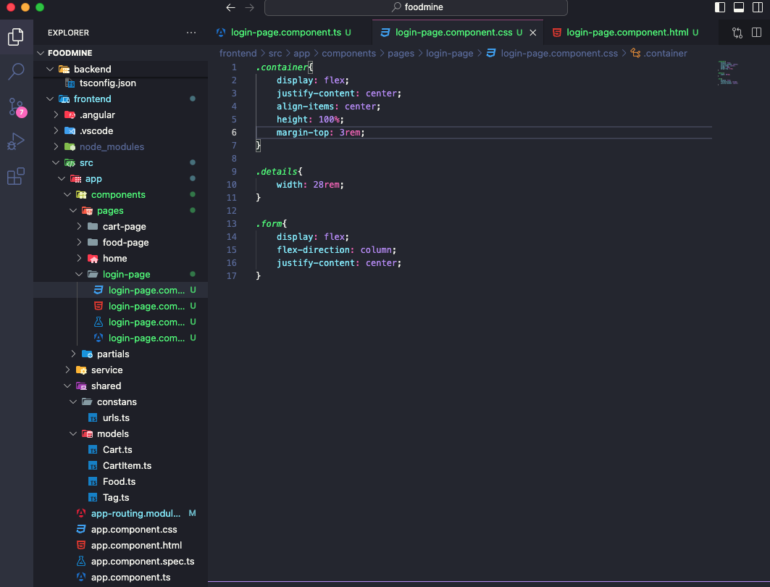

Add login backend

*npm install jsonwebtoken*

